From: http://davidstockmanscontracorner.com/trumpian-boom-r-i-p-part-2/

Trumpian Boom R. I. P. (Part 2)
By David Stockman. Posted On Wednesday, January 16th, 2019
The Donald never had a snowball's chance in hell of Draining the Swamp---let alone making MAGA. So Flyover America is fast on its way to being betrayed yet again.
This should have been evident all along because from day one Trump lacked even a simulacrum of a program to rectify America's failing economy. And Trump-O-Nomics isn't a policy---it's a dog's breakfast of Trade War and Border War populism and about the worst combination of fiscal debauchery and monetary profligacy ever proposed.
The now fading stock market boom of Trump's first 22 months, therefore, wasn't even remotely the kind of well considered endorsement of Trump-O-Nomics that you can take to the bank.
To the contrary, it was just one last rip of Wall Street's army of gullible speculators and momentum chasing robo-machines. The latter have been rewarded by central bank liquidity injections, financial repression and price-keeping operations for so long that they could probably get bulled-up on a plan to harvest green cheese from the far side of the moon.
In fact, what we are dealing with on both main street and Wall Street is not responses to the Donald's policies and palaver at all, but simply residual momentum. Both the in-coming macro-data and the stock indices are essentially tracking the "last mile", so to speak, of the trends----business cycle expansion and rising bull market--- which have been in motion for nearly a decade.
Needless to say, these post-crisis debt and bubble driven trends are anything but healthy and are clearly not sustainable. They inhabit a financial fantasyland confected during a decade of the most reckless fiscal and monetary policies ever conceived.
So the very idea of boasting about the data prints of a badly impaired 115 month-old business expansion and a speculation driven 119 month-old bull market smacks of rank amateurism and stunning political naiveté. It's as if the Donald is joyfully carrying around a platter and inquiring about where exactly to place his head.
Too Late To Brag---The Cycle's 112 Months Old And Expiring
What we mean is that when you are at the top of the second longest business cycle in history, it is far past the time to be bragging about the current economy and the allegedly good data flashing in the rearview mirror; and imperative, instead, to assess the headwinds coming at the windshield and their implications for steering the vehicle.
That's especially because the headwinds facing the current aging cycle are ferocious compared to what prevailed when the record 119 month run of the 1990s finally rolled over into recession in March 2001.
Back then, there were virtually no macroeconomic headwinds visible. The Federal budget was in surplus; the Fed had finished its tightening cycle at a 6.5% funds rate nine months earlier; Europe was busting out of the single-currency starting gates; and the Red Ponzi was just finding its export sea legs and had only $2 trillion of debt.
Today's circumstances are the opposite----with massive headwinds accumulating like never before. The US Treasury will be borrowing $1.2 trillion this year; the Fed is still at a 2.13% funds rate and way behind the curve; the European economies are again rolling over and global trade is slowing sharply; and the Red Ponzi sits precariously atop $40 trillion of debt and an economy drowning in wasteful malinvestment, hideously inflated real estate markets and inexorably slowing GDP growth.
With the cycle at 115 months of age, therefore, any of those headwinds could trigger a downturn. But in combination they make the odds of a US recession during the next 12-24 months overwhelming.
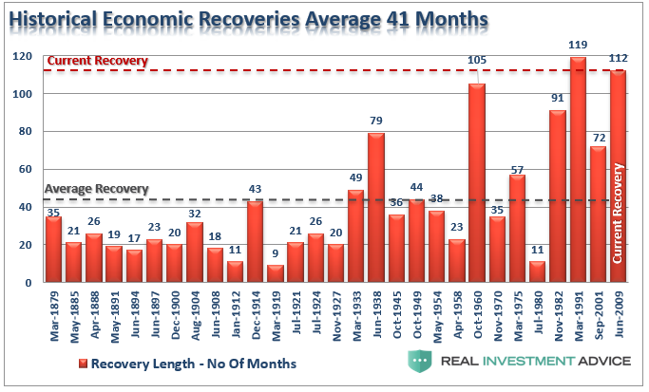
Needless to say, there is nothing strategic or even tactical about the Donald's foolish embrace of an aging stock market bubble and wizened economic cycle. It's just a glandular lurch---the impulsive action of an incorrigible megalomaniac grasping for anything which can be portrayed as a personal "win", including even dodgy successes (like the U-3 unemployment rate) that are sure to implode at any moment in time.
In fact, the Trump Bump---which the Donald has embraced with all fours---will prove to be the most lunatic stock market mania of modern times. As its implosion now gathers force, even the casino revilers will soon be shaking their heads in a grand consternated chorus of "what were we thinking?"
What kept the insane Trump Bubble going as long as it did, of course, was nine-years of embedded mental muscle memory in the casino. The latter held that buying the dip always---but always---results in a profitable gain.
And that's especially so if you are a Wall Street insider speculating with the various forms of carry trade leverage available in the options market or from the bespoke trading desks of Goldman and the other big gambling houses.
Indeed, if you survived the plunge between the Lehman bankruptcy in September 2008 and the March 2009 bottom, there were literally 50 buyable dips during the years of fabulous gains which followed. Getting rich had never been so easy.
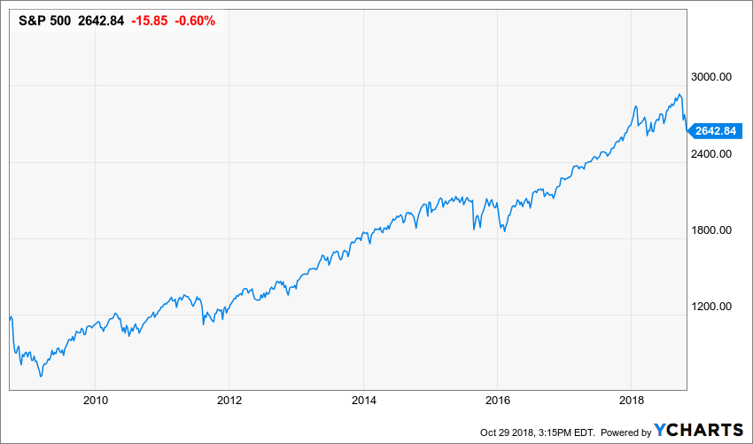
The one-way market depicted in the graph above, of course, was not on the level. It was the malefic handiwork of the Fed and its global convoy of fellow-traveling Keynesian central bankers. Its extended run in financial fantasyland finally extinguished every remnant of fear in the casino---until some time in early October when the last mullets standing presumably took the bait.
The Chart-Monkeys Will Go Screeching Out Of The Casino
Now comes the reckoning, and at the mechanical level its not all that complicated. When there are no dip-buyers left---why then the trading charts get eviscerated and the chart-monkeys go screeching out of the casino.
To wit, back on October 3rd when the S&P 500 re-tested its September 20 Trump Bump peak at nearly 2930, the index was safely above its alleged multiple layers of support; it had printed 2% above its 50-DMA, 6% above its 200-DMA and 11% above its 350-DMA (50 week).
Yet during the next 65 trading days thru Christmas Eve, the index plunged through its vaunted supports like a hot knife through butter. Every one of them was blown away including the 50-week average, which is considered the absolute Maginot Line by the chart monkeys.
And that was only a forewarning of the potential for a sickening freefall which lies ahead. After all, when you finally reach a bubble's asymptote there is no one left up there in the nosebleed section of the casino except other sellers.
Nor in the present circumstance is accelerating economic growth and rising profits going to save the day. That's because the Donald's allegedly booming main street economy is no more real or sustainable than was the stock markets' last rip.
The truth is, the main street economy went essentially nowhere during the radically lopsided post-crisis recovery since June 2009. And, aside from short-run aberrations in the recent headline GDP numbers which resulted from the Trump's impending trade wars and tax cuts financed by Uncle Sam's credit card, it has not accelerated in the slightest.
For example, the chart below shows seasonally adjusted annualized rates of change for real final sales.
The latter is a more stable and indicative figure than real GDP because it excludes highly volatile quarter-to-quarter changes in the rates of inventory stocking and destocking, which essentially wash-out to zero over any meaningful period of time.
You don't need a calculator to see that there is essentially no difference in the fluctuating quarter-to-quarter growth rates during the past seven quarters of the Trump economy compared to the last 20 quarters during the Obama presidency after the US economy had dug out from the Great Recession.
In fact, the average real final sales growth rate under Obama was 2.20% per annum and under Trump it's been 2.35%. We'd call that close enough to the same thing for government work and also tepid on both accounts.
Moreover, the more salient point is that 90% of the gain depicted by each of the red bars below reflects not the fruits of White House policy machinations, but the workers, entrepreneurs and companies of capitalist America pushing the ball of economic activity forward yard-by-yard, quarter after quarter.
Indeed, the great scam of the present era is the bipartisan lie under which Washington policy makers take full credit for growth and jobs, as if the $20 trillion American economy would be one great big stagnant void without monetary and fiscal stimulus from Washington.
Bipartisan Tommyrot----Washington Doesn't Cause Economic Recovery Or Growth
That's tommyrot. As we demonstrate below, monetary stimulus after 2008 essentially never left the canyons of Wall Street. And fiscal deficits never really stimulate unless they are monetized by the Fed, but in today's world Fed bond-buying only fuels financial asset inflation, not main street activity.
In fact, the only contribution to growth attributable to either of these presidents is a negative one. That is, both Obama and Trump heavily mortgaged future taxpayers as they attempted to inject borrowed spending power into the short term GDP prints.
But that's nothing to boast about since these obligations will eventually take a far greater toll in debt service payments and reduced growth over the indefinite future.
In any event, there is no more comprehensive measure of current activity rates in America's $2o trillion economy than real final sales. And by that core metric the main street economy was essentially chopping slowly forward under Obama.
Alas, that punctuated pace of slow advance has not accelerated one bit since the Donald moved into the Oval Office---including the mere 1.0% growth rate of the most recent quarter (Q3 2018).
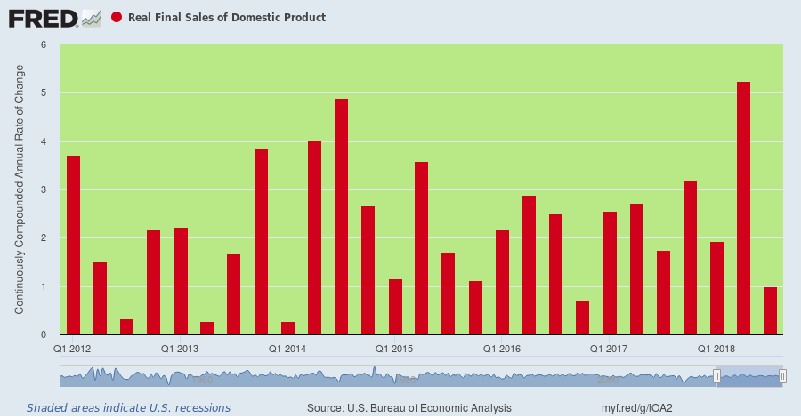
Most of the Donald's boasting about the "greatest economy ever" amounts to claiming credit for the daily sunset. Thus, having entered office at the top of a labored but long running business expansion, which is now in month #115, Trump inherited 83% of the improvement in the unemployment rate shown below between the 10.0% recessionary peak posted in early 2010 and the 3.7% rate posted a few months ago.
To be sure, the U-3 unemployment rate is a pretty lousy statistic and misleading measure of labor market conditions for reasons we detail below. But notwithstanding its manifold defects, it is self-evident that the U-3 unemployment rate tracks the natural growth of American capitalism during a business cycle expansion, and that there has been no meaningful acceleration from the pre-existing downward trend since January 2017.
Technically speaking, in fact, during 2010-2016 the unemployment rate declined by 0.7% per month and during the first 22 months on the Donald's watch the decline averaged 0.6% per month.
Likewise, on a nonfarm payroll count basis, the jobs gains was 208,000 per month during Obama's last 22 months and 196,000 per month during the first 22 months on the Donald's watch
Unless you have the GOP talking points, therefore, this chart will give you no hint as to when the Donald took over and turned around the failing Obama economy. That's because he actually didn't.
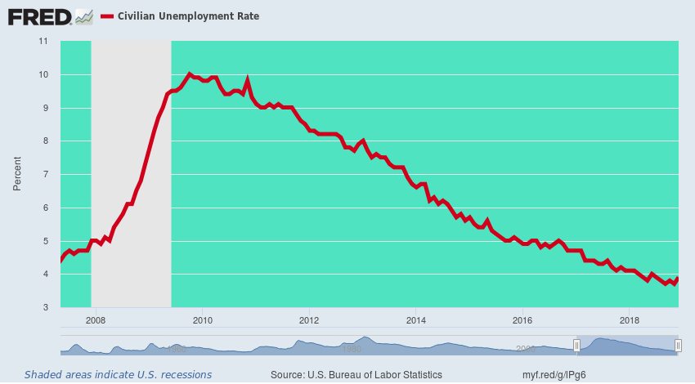
Accordingly, the above chart is not any kind of success marker at all; it's a clanging warning bell that unless the economic gods have abolished recessions, the likely future direction of the red line in the graph is up, and smartly so.
History Lesson: 3.7% Unemployment Always Marks The Cycle's End
Actually, there have been only two other business cycles in modern history that even breeched the 100 month duration marker. The first of these was the Kennedy-Johnson "guns and butter" expansion of the 1960s, which lasted 105 months and is encompassed by the green area of the panel shown below.
But as also shown by the red line marking the U-3 unemployment rate, within barely a year of hitting 3.7%, the US economy had tumbled into recession.
In short, when the unemployment rate plunges below 4.0% there usually isn't much time left on the cyclical clock. So what's actually warranted is focus on the recessionary troubles ahead, not a boast about riding the unemployment rate to the final monthly bottom.
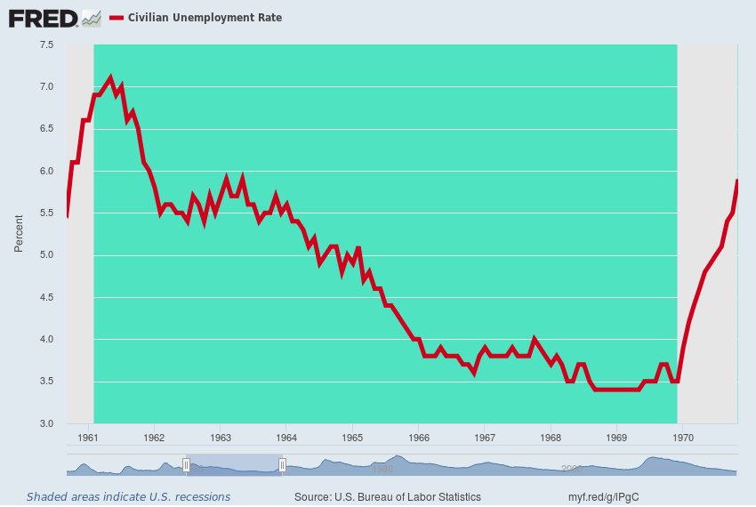
Indeed, this plain old business cycle fact of life has been thoroughly lost on the Donald, although you might think that his multiple brushes with bankruptcy, which occurred during economic downturns, might have at least sensitized him to that unassailable reality.
Still, the cyclical story has been the same over and over: Peak performance levels are reached repeatedly and downturns always ensue.
Indeed, the other long (and record) expansion represented by the Greenspan Fed-fueled tech boom of the 1990s, which lasted 119 months, provides an even starker warning than the 1960s go-round.
That time the U-3 hit its low of 3.8% in April 2000, but what had been the genuine booming economy of the 1990s was in recession 11 months later. And we do mean booming: real GDP had grown at a 4.0% year-over-year rate for 16 straight quarters before April 2000.
Needless to say, the rearview mirror gazers of that era didn't see a recession coming, either. And for a reason that is absolutely on point at present.
To wit, the rolling stock market crash after March 2000 is what brought the main street economy down as the corporate C-suites began to throw employees, inventories and "impaired" assets overboard in an effort to propitiate the Wall Street trading gods.
The bursting of central bank fostered financial bubbles, in fact, is the new catalyst for recession, meaning that charts like this one are lagging indicators waiting to be monkey-hammered by the next Wall Street crash.
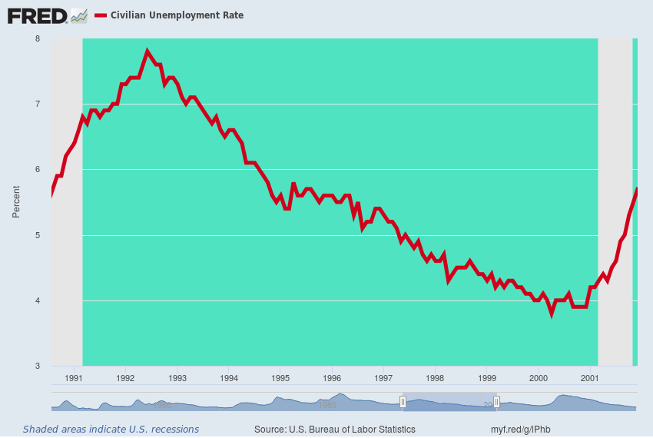
If [It] could not be more evident that once a long expansion is in motion, the BLS' primitive U-3 unemployment rate inexorably drops toward the lower right of the green panels displayed above. That is, the red line (U-3 unemployment) essentially embodies cyclical gravity at work---propelled by the underlying forces of capitalist growth.
Indeed, about the only thing different about the U-3 trend chart for 2010-2018 compared to those for the 1960s and the 1990s is that the putative "last mile" has not yet been recorded. That is to say, it will likely take only a few more months for the green space of expansion to give way to the next recession and a rapid upturn in today's ballyhooed 3.7% unemployment rate.
So the cyclically bottoming U-3 unemployment rate was in motion long before the Donald shuffled into the Oval Office and his relatively brief tenure to date has absolutely nothing to do with it. If anything, it is another bright red cap heralding that what comes next is, in fact, not MAGA!
Best Wage Gain In Years My Eye
The same kind of cyclical fortuity pertains to the Donald's boasting about workers finally getting a wage gain, as purportedly reflected in the most recent year-0ver-year gain of 2.8%.
In fact, when the unemployment rate hit 3.7% in September, the year-over-year nominal wage gain (red line) was about at the lowest point it's been since the late 1960s; and in real terms, the story is even worse.

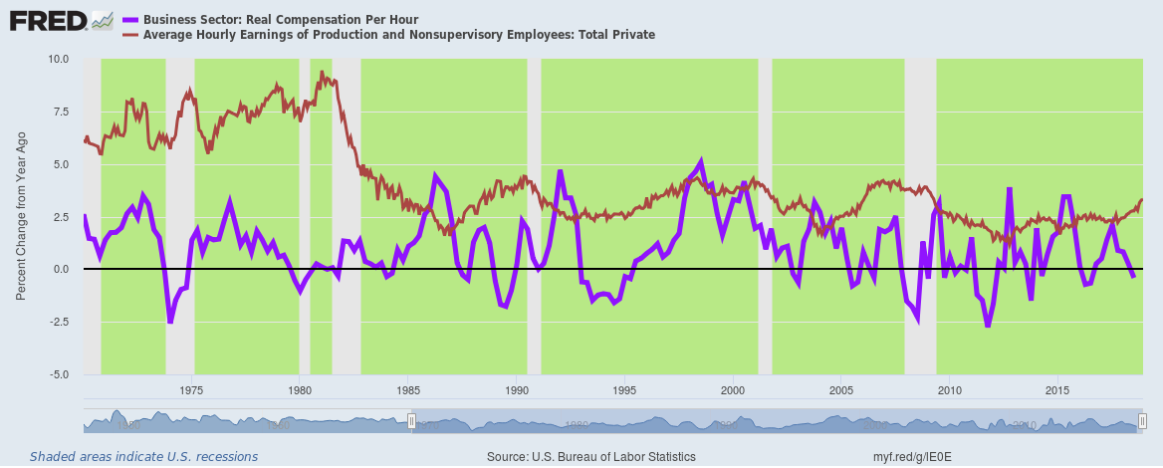

To wit, between 1955 and 2000, inflation-adjusted compensation per hour (purple line) grew at a 1.75% annual rate----and that's the average across seven business cycle[s], including recession years.
By contrast, we are now at the top of the second longest business expansion in history, and real compensation was up just 0.1% over the 12 months ending in September. That's not even up---it's a rounding error.
That's right. Siting check-by-jowl at the no change level, the purple line above shows that year-over-year real wage growth has now clocked in at virtually the weakest late cycle gain on record.
Actually, the Donald's boasting about what amounts to a cyclical gain in jobs is all the more ironic because during the campaign he trashed the very BLS numbers (and appropriately so) that he now brags about. At one point he even cited our own view that the only meaningful measure of unemployment is the share of total potential adult labor hours that are not employed in the monetized economy.
As we will document in Part 3, the number currently happens to be about 40%!

